Incremental Refresh (Comparison of Refresh Time)

1. Firstly , Created two reports in Power BI Desktop

One with Incremental Refresh,

Another one is normal (Refreshing whole dataset each time)

1. After Publishing to the Power BI Service :

Workspace Name : PBI-Embedded-2023

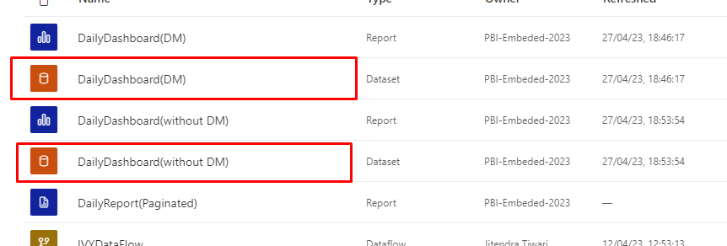

Refresh History table of Incremental Refresh Dataset:

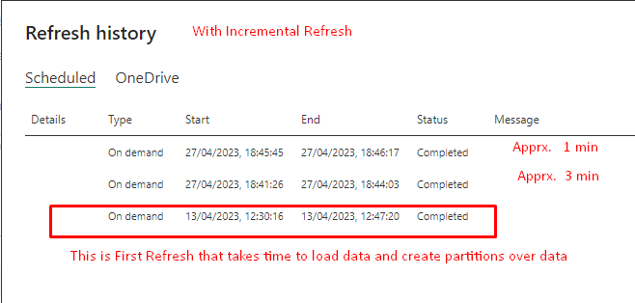

Refresh History table of whole Dataset:

